PortSwigger Web Security Academy — Proof of Concept

Prototype Pollution Lab 6

Server-side prototype pollution via JSON body
Category | Prototype Pollution
Lab | Lab 6
Completed By | Security Researcher
Platform | PortSwigger Web Security Academy

Lab Objective
Exploit server-side prototype pollution via JSON request body to elevate privileges.

Step-by-Step Exploitation
- Log in and visit your account page. Submit the form for updating your billing and delivery address.
- In Burp, go to the Proxy > HTTP history tab and find the POST /my-account/change-address request.
- Observe that when you submit the form, the data from the fields is sent to the server as JSON.
- Notice that the server responds with a JSON object that appears to represent your user. This has been updated to reflect your new address information.
- Send the request to Burp Repeater.
- Identify a prototype pollution source
- In Repeater, add a new property to the JSON with the name __proto__, containing an object with an arbitrary property:
- "__proto__": {
- "foo":"bar"
- }
- Send the request.
- Notice that the object in the response now includes the arbitrary property that you injected, but no __proto__ property. This strongly suggests that you have successfully polluted the object's prototype and that your property has been inherited via the prototype chain.
- Identify a gadget
- Look at the additional properties in the response body.
- Notice the isAdmin property, which is currently set to false.
- Craft an exploit
- Modify the request to try polluting the prototype with your own isAdmin property:
- "__proto__": {
- "isAdmin":true
- }
- Send the request. Notice that the isAdmin value in the response has been updated. This suggests that the object doesn't have its own isAdmin property, but has instead inherited it from the polluted prototype.
- In the browser, refresh the page and confirm that you now have a link to access the admin panel.
- Go to the admin panel and delete carlos to solve the lab.

Screenshots & Evidence
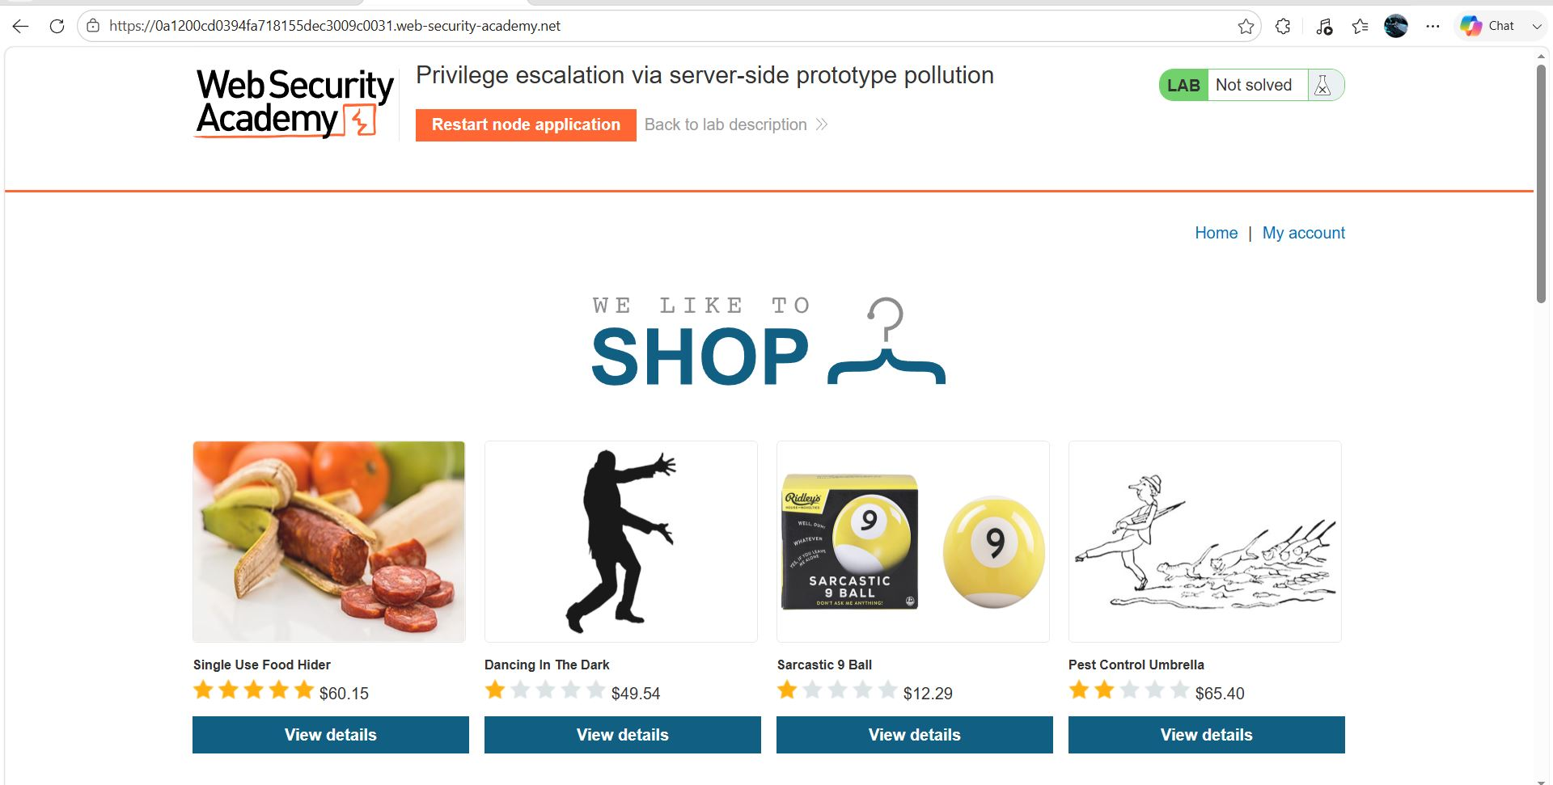
Figure 1: 1 Image
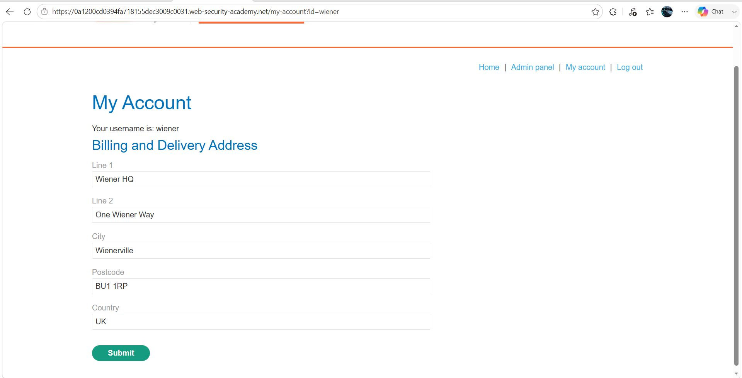
Figure 2: 2nd Image
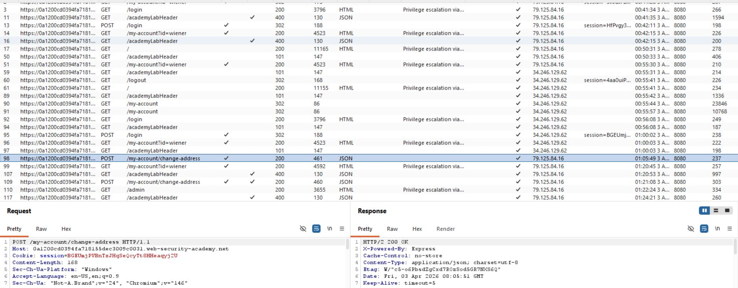
Figure 3: 3 Image
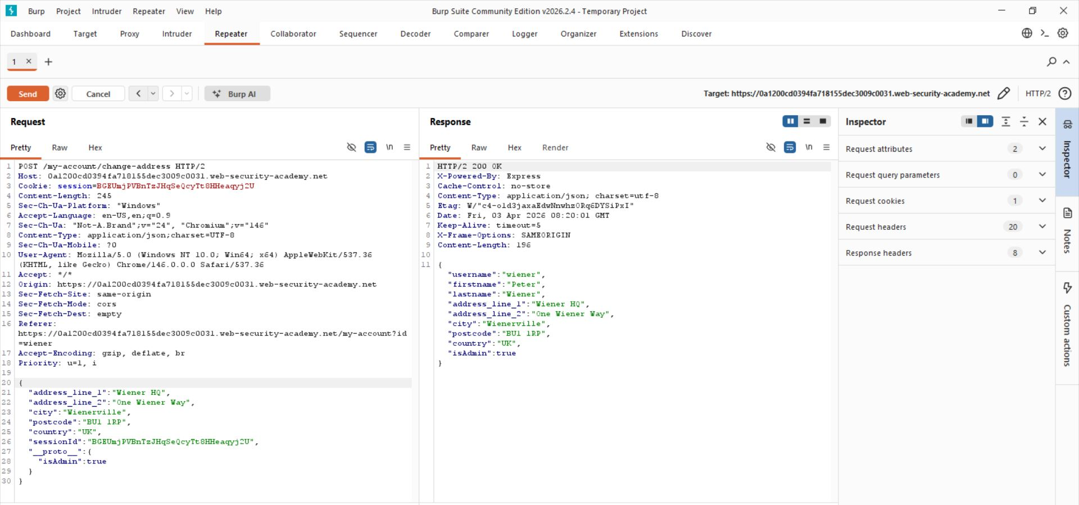
Figure 4: 4 Image
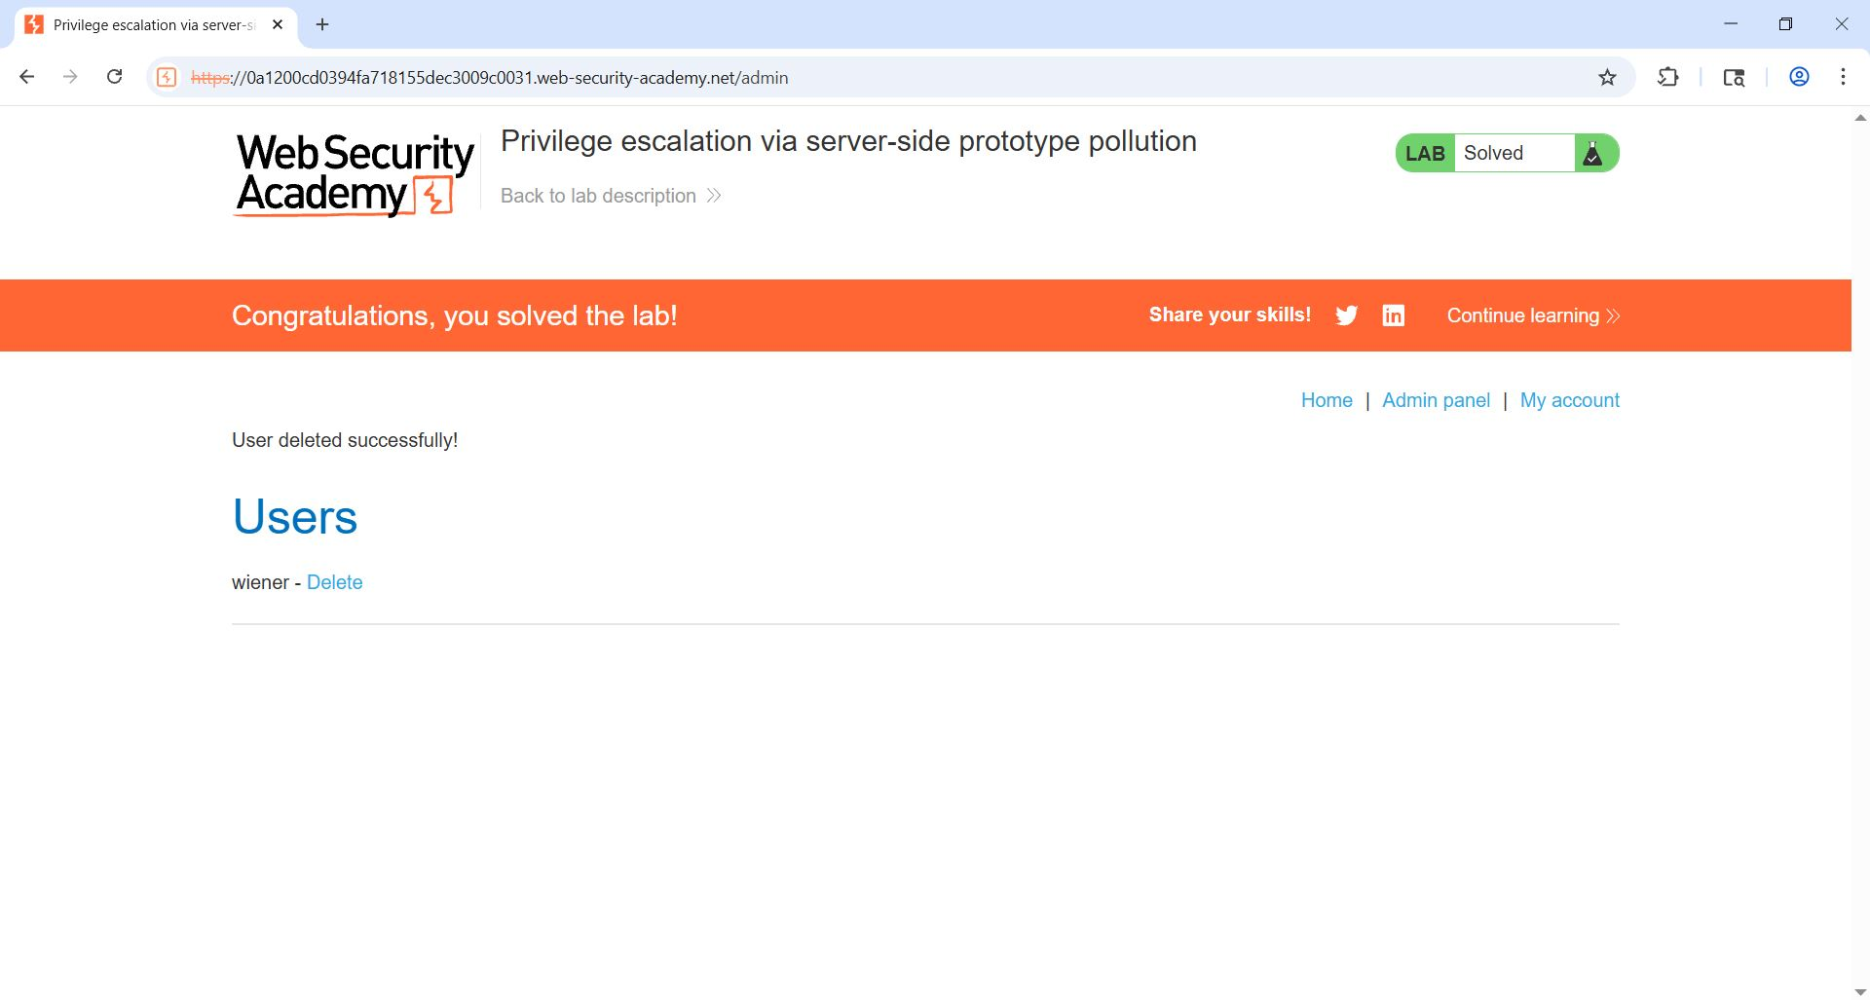
Figure 5: Laast Image
Lab Solved — Confirmation
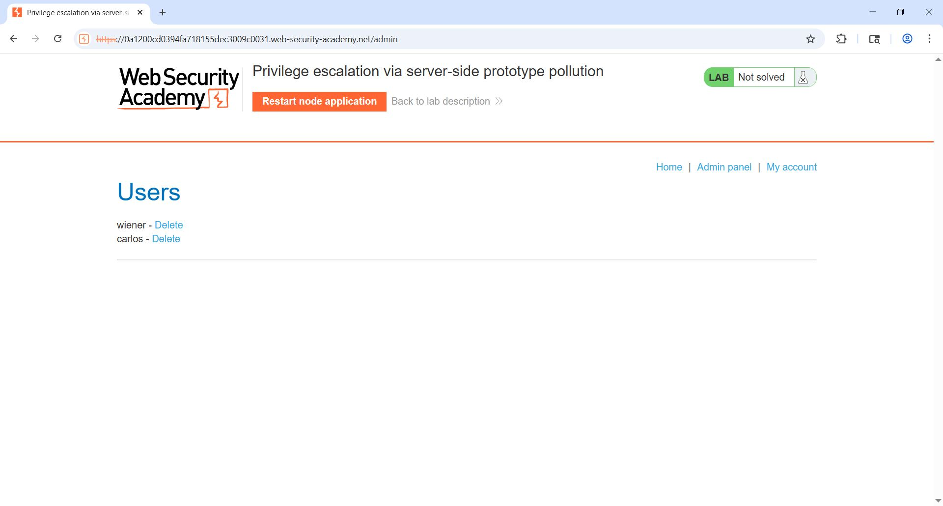
Figure 6: Last 2ns

Lab Status: SOLVED

